# Target Metrics

Overall - Accuracy: 0.8100, Precision: 0.8208, Recall: 0.8100, F1: 0.8060

Class-specific metrics:

Carbon neutral(ity) - Precision: 0.8095, Recall: 0.6800, F1: 0.7391

Emissions reduction target - Precision: 0.8947, Recall: 0.6800, F1: 0.7727

Net zero - Precision: 0.8519, Recall: 0.9200, F1: 0.8846

No target - Precision: 0.7273, Recall: 0.9600, F1: 0.8276

# Year Metrics

Overall - Accuracy: 0.8300, Precision: 0.8481, Recall: 0.8300, F1: 0.8308

Class-specific metrics:

2020 - Precision: 0.0000, Recall: 0.0000, F1: 0.0000

2022 - Precision: 0.0000, Recall: 0.0000, F1: 0.0000

2025 - Precision: 0.7500, Recall: 0.6000, F1: 0.6667

2030 - Precision: 0.8750, Recall: 0.8400, F1: 0.8571

2031-32 - Precision: 0.0000, Recall: 0.0000, F1: 0.0000

2032 - Precision: 0.0000, Recall: 0.0000, F1: 0.0000

2035 - Precision: 0.8000, Recall: 0.8000, F1: 0.8000

2040 - Precision: 1.0000, Recall: 1.0000, F1: 1.0000

2050 - Precision: 1.0000, Recall: 0.7778, F1: 0.8750

No specific year mentioned for carbon neutrality, but 2040-2050 is mentioned as the time frame for decarbonization - Precision: 0.0000, Recall: 0.0000, F1: 0.0000

No target - Precision: 0.7273, Recall: 0.9600, F1: 0.8276

No target year mentioned - Precision: 0.0000, Recall: 0.0000, F1: 0.0000

# Other Metrics

Quote Accuracy: 0.7800

Overall Accuracy: 0.7700

Valid XML Percentage: 1.0000

# Confusion Matrices

Target Confusion Matrix:

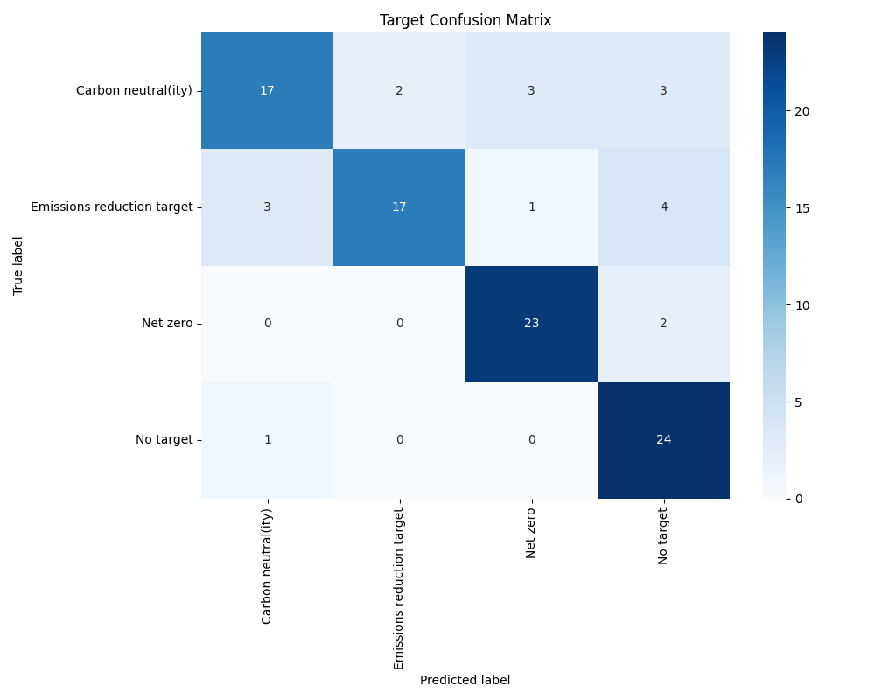

Year Confusion Matrix:

